## Module 12 nosql-challenge - screen shots v1

Raj Agrawal / SMU DS / July 2023

===

**## Deliverable 1:** Part 1: Database and Jupyter Notebook Set Up

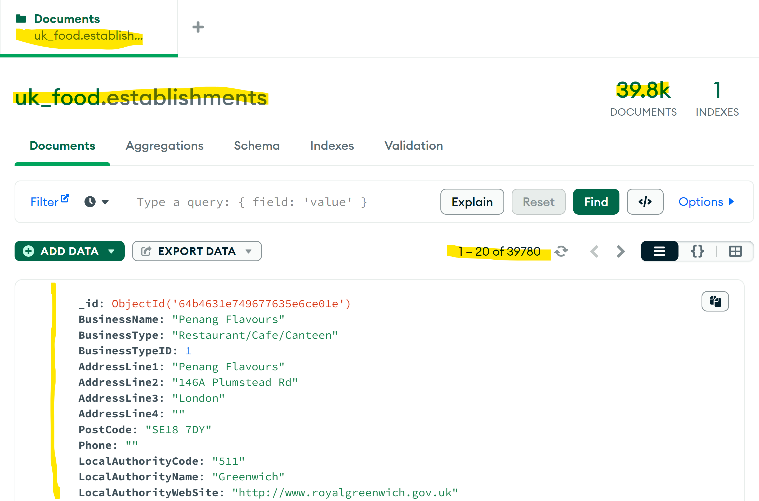

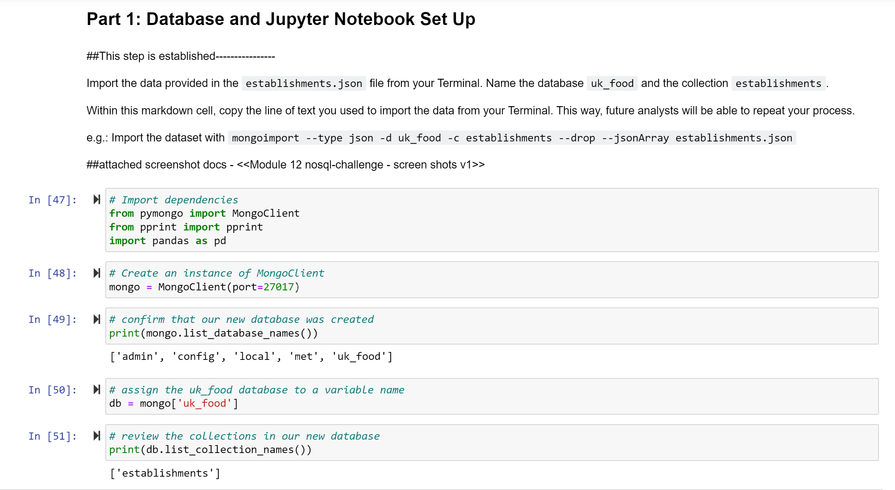

***LocalAuthorityName as “Dover”***

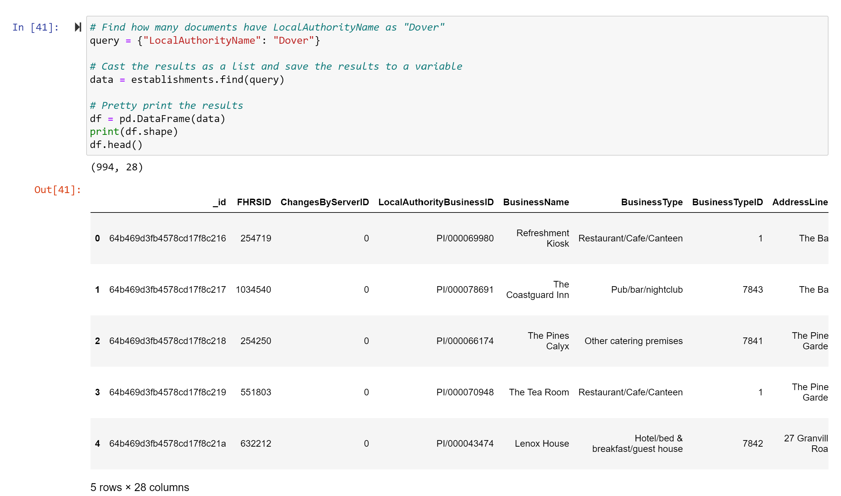

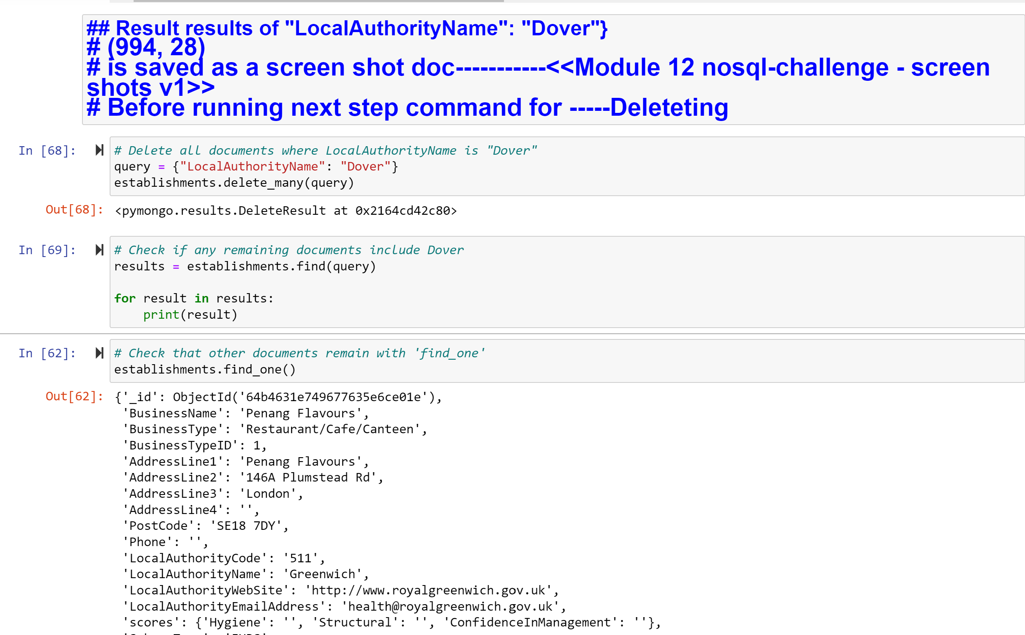

**## Deliverable 2:** Part 2: Update the Database

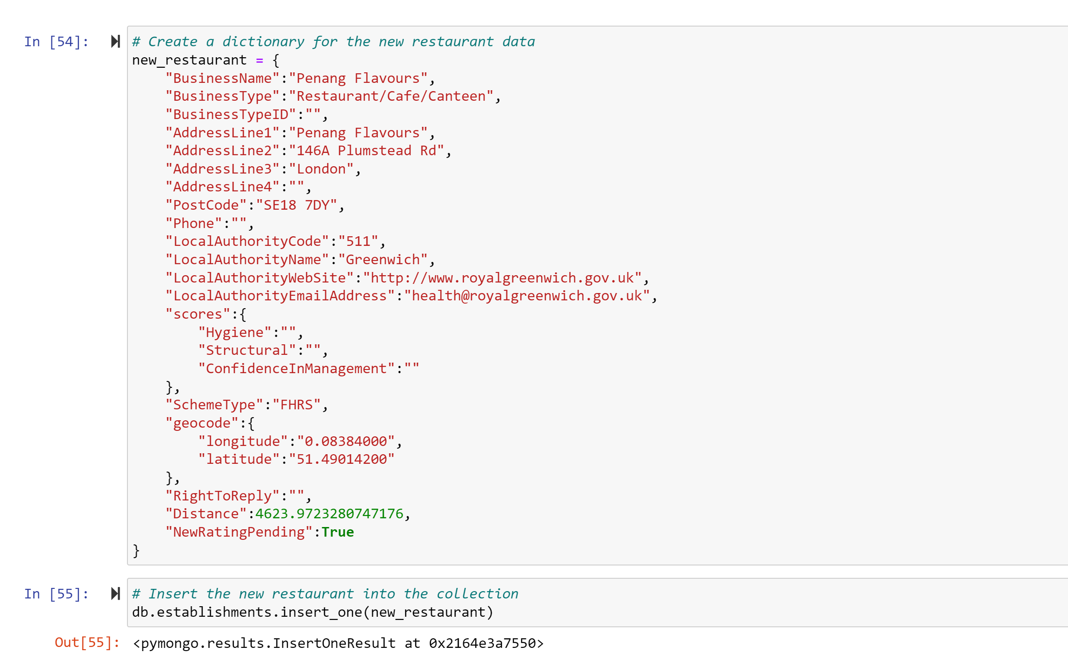

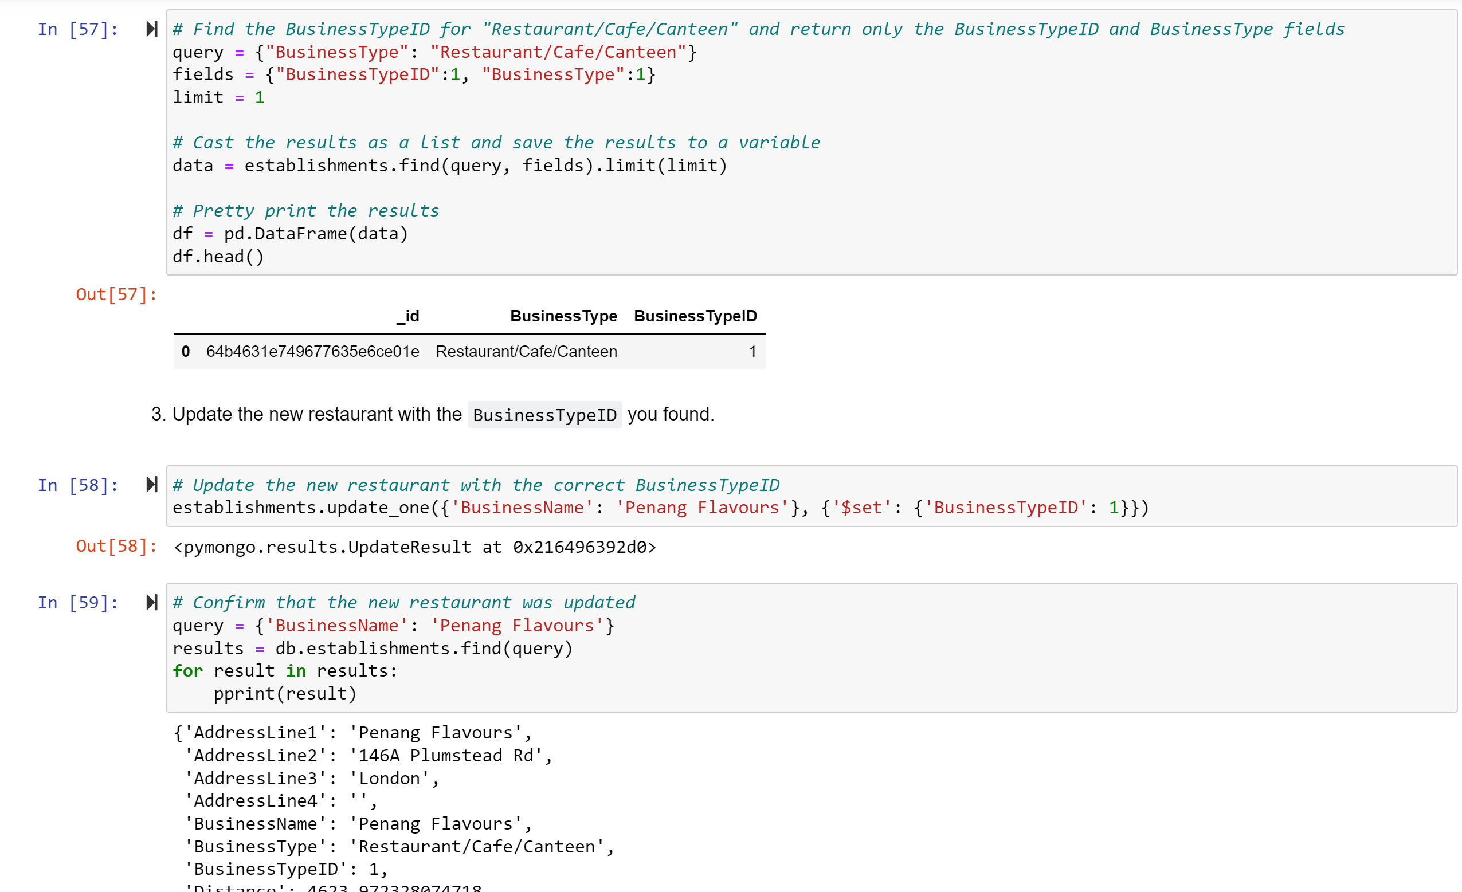

## ## Deliverable 3: Part 3: Exploratory Analysis

## 

## 

## 

